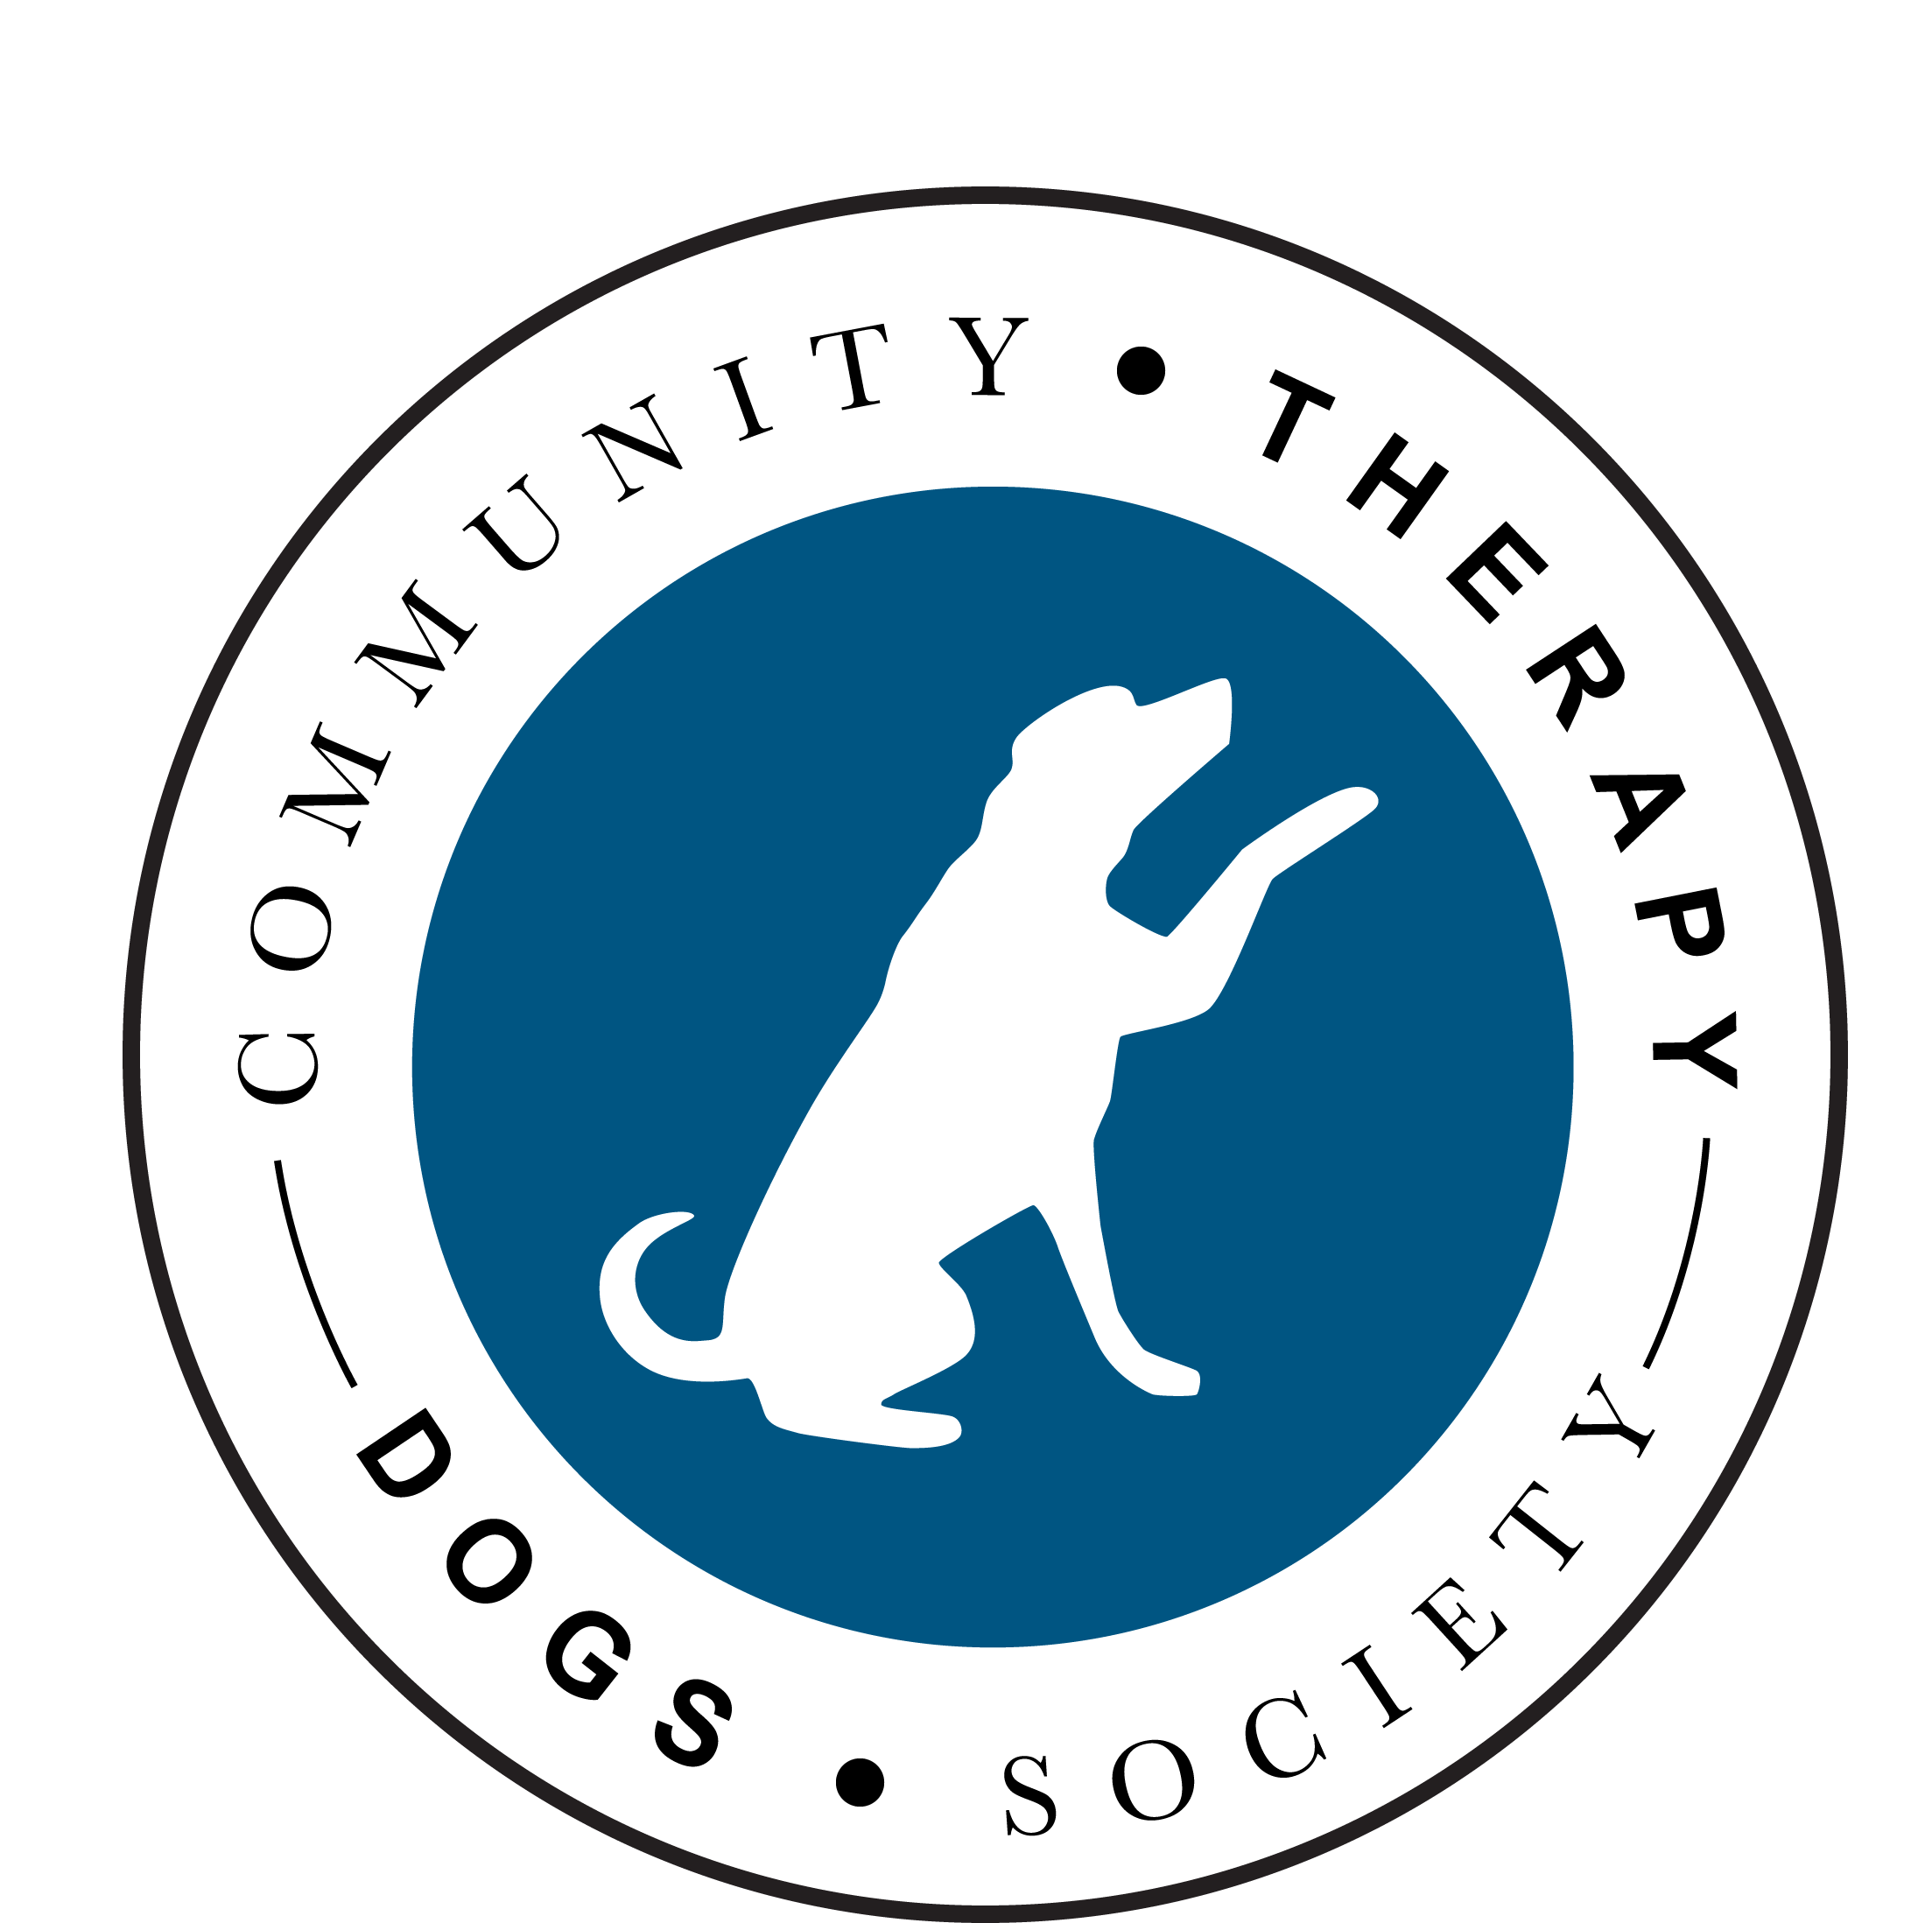
VOLUNTEER APPLICATION FORM

Name:

Address (inc postal code):

Email address:

Cell phone #: Home phone #:

Birthday (Month/Day):

Name of dog: Breed:

Dog’s date of birth/ age:

IMPORTANT: if your dog is fed ONLY raw meat, it will not be accepted onto the CTDS program.

How would you like to help volunteer with CTDS?
- With a dog:

Listening Tails Visiting Tails Caring Tails

- Without a dog:

Fundraising Administration Community Events

Other (specify)

When are you available? (specify):

How did you hear about CTDS?

